*Blank page-Do Not Print*



NEWS BULLETIN

*May 19 & 20, 2018*

***Pentecost***

*CHURCH:* 803 Swifts Hwy, Jefferson City, MO 65109 • (573) 636-6750 • churchoffice@trinityjc.org

*SCHOOL:* 812 Stadium Blvd, Jefferson City, MO 65109 • (573) 636-7807

trinityjc.org • facebook.com/trinitylutheranjc

|  |  |  |
| --- | --- | --- |
| We remember  in our prayers  **Our homebound members:** Rose Appelbaum, Allen Beck, Lou Case, Mae Conelley, Anne Cook, Arline Foster, Marjorie Erckman, Dorothy Gretlein, Max Hedglin, Norma Hirschman, Wilma Keiser, Jackie Ochs, Elaine Patterson, Barbara Sullivan, and Leila Todd  **Our military:** Eric Bauer, Justin Grell, Lacey Hartman, Austin Kutscher, Cameron Maasen, Cameron Sanford, Josh Suthoff, Keith Taylor, Grace White  **Those hospitalized:**  Susan Fife (Oak Tree), Arline Foster & Dorothy Lauten (St. Joe)  Please also keep **college and church work students** in your prayers.  *Your prayer requests are welcomed and encouraged! Call the church office or email Denise Ziegelbein at* keithdenisez@gmail.com. | Thank you  **A special thank you** to the seventh and eighth graders who folded the bulletins every Friday. Summer break starts this week, so if you are looking for a way to serve, but only have an hour here or there, we are looking for helpers to fold worship bulletins on Fridays.  *If you would like to sponsor bulletins*  *(suggested donation is $50)*  *or provide altar flowers for a weekend,*  *there is a sign-up in the hallway.*  Meetings  **Tues, May 22 – 6:30 p.m.**  Church Council meeting  **Tues, June 5 – 7:00 p.m.**  Voters' Meeting  **SUMMER WORSHIP SCHEDULE**  Beginning the weekend of Memorial Day through the weekend of Labor Day: | |
| *Divine Services:*  Saturday, 6:00pm  Sunday, 9:30am | *Bible Study/SS:*  Sunday, 8:30am |

|  |
| --- |
| **Attendance & Giving** |
| **LAST WEEK’S ATTENDANCE:**   |  |  |  |  |  | | --- | --- | --- | --- | --- | | 6:00 p.m.: | 114 | Total: | 485 | | | 8:00 a.m.: | 239 | Guests: | 26 | | | 10:30 a.m.: | 132 |  | |  |   *Don’t forget to fill out attendance pads!* |
| **GENERAL OFFERING**  **(2017-18 FISCAL YEAR)\***   |  |  |  | | --- | --- | --- | |  | **Last Week** | **YTD** | | **Actual** | $12,928.84 | $724,553.31 | | **Budget** | $14,808.69 | $681,199.74 | | **Over/Under**  **Approved Budget** | ($1,879.85) | $43,353.57 | |
| *\*Please note that the numbers referenced are only the weekly offerings section of the budget.*  General Fund owes Building Fund $10,259.54 |

**WELCOME!** The following individuals are being welcomed into the congregation through adult confirmation:

• Liz Johnson

• Josh & Candice Frates with children Isabella, Sophia, and Micah

• Andrea Dockins with daughter Addison

• Dan Delong

• Brandon & Jana Ruediger with son Trey

**FUNDRAISER:** Heisinger and St. Joseph Bluffs Auxiliary will be holding a fundraiser Saturday **June 2nd** from 4:30 to 7:00 at the American Legion Hall 1423 Tanner Bridge Road. The Menu is Fried Chicken or Roast Beef, sides, and dessert. Adult tickets are $11.00 and children (5-10) are $5.00. Tickets can be purchased in advance from the Heisinger Bluffs office or from Auxiliary members. Proceeds benefit the residents of Heisinger and St. Joseph Bluffs.

**CARPET INSTALLER FOR THE NURSERY:** Amanda Peters' dad (Chris Bear) graciously donated carpet for our nursery from Dugan's Paint and Flooring in Sunrise Beach, MO. We are now in need of someone who would be able to donate their time to install the carpet for us! Please contact Aubrey Hobratschk at 660-864-3160.

**HOSTS NEEDED:** On June 9-10, Trinity will have music groups from Living Word Lutheran High School in Jackson, WI join us in worship as they travel on their tour. We are in need of hosts to provide a place for the students to stay that Saturday evening. Please contact Caley Gerth if you would be able to help!

**USHER TEAMS:** There will be a meeting for all ushers on Thursday, **May 24** at 6:30 pm in the Fellowship Hall to discuss the new summer schedule and items from the recent security meeting.

**LUTHERAN BLIND MISSION:** The Lutheran Blind Mission members wish to THANK an anonymous donor for the recent meals provided along with the meal on the trip to Hermann, along with those who have provided meals previously.   Assistance could always be used for the provision of Meals on the Second Saturday of the month.  Maybe you or a group of your friends could assist, could you help with providing a meal and assist with serving?  Volunteers are always needed for transportation.  Thanks again for all those that have helped.

**SILVER SNEAKERS:** If you’re looking for convenient fitness options, the YMCA offers a strength and balance class on Tuesday and Thursday mornings at 9:00 am here at Trinity Lutheran Church. Join Charlene for a low-impact 45 minute workout that will improve your health and fitness in a safe environment. Plus, if your insurance carries the Silver Sneakers benefit, or if you are a YMCA member, the class is free! If not, it is only $20/month. For more information, you can call the YMCA at 761-3459 or Charlene at 338-4079.

**COUPON CUTTERS** will have a display next Sunday showing the purchases made during the month of May.  Please take a detour around the chairs in the entryway to take a look at what we, no ***YOU***, have done with your contributions toward helping others in the community.

**BULLETIN BOARD IN THE LOBBY:** Pentecost gave everyone an opportunity to hear the Gospel in their own language. The bulletin board in the lobby has the Gospel in 26 languages. Can you find yours?

**HEIT’S POINT OUTDOOR FESTIVAL**: Save the date! Rev. Dr. Brian Friedrich, President of Concordia University, Seward, NE will be the guest speaker at our annual Festival on June 10 with this year’s theme being “Journey”. The Festival kicks off at 9AM with coffee & cinnamon rolls and tours of the camp. At 11AM the Worship Service will begin and led by Rev. Dan Wing, Pastor at St. Paul’s Lutheran Church in Concordia, MO. At noon we will begin serving BBQ brisket or chicken quarters, potato salad, and baked beans prepared by staff at Heit’s Point. A Silent and Live Auction will be held with the Live Action beginning around 1PM. A youth carnival will also be available. The Festival will wrap up with the serving of cobbler and ice cream. Come and enjoy a day filled with worshiping God, eating delicious food, having fun and fellowship with old and new friends, and enjoying God’s beautiful creation!

**COLLEGE/ YOUNG ADULT BIBLE STUDY:** Inviting all college-age students and young adults to join us for Summer Bible Study every Wednesday night at 7:30pm! We are excited to have returning students back with us and welcome you anytime. For more information please contact Megan Hinck at megan.hinck@gmail.com or (816) 716-3633.

**COLLEGE YOUTH GROUP CROSSOVER EVENT:** All senior high school students who have recently graduated are invited to join our college youth group! Please join us Wednesday, June 13th at Break the Code Adventures for a fun escape room. We will meet at Trinity's youth room at 5:15pm. Cost is $5 per person. Please RSVP to Megan Hinck at megan.hinck@gmail.com or call/text (816) 716-3633.

**LIFE QUOTE FOR THE WEEK**

**May 20**

“We celebrate when a mother has second thoughts concerning abortion and keeps her baby. We sing ‘Alleluia’ when an orphaned child once abandoned is adopted and lives in a home filled with the presence of Christ’s love reflected through a mother and father.”

*-* *Chaplain (Lt. Colonel) Steven Hokana, Assistant Director of Ministry to the*

*Armed Forces (MAF) (LCMS)*

A Life Quote from Lutherans For Life

www.lutheransforlife.org

**LIFE THOUGHT IN THE CHURCH YEAR**

**Pentecost**

“I will pour out my Spirit on all flesh” (Acts 2:17a). The Lord embraces sons and daughters, young and old. Every human being, whatever her shape and size, exists to reflect the goodness of God’s will that made her. Every human being, no matter his faculties or functions, witnesses to the authority of God’s Word that brought him forth. May this incontrovertible truth issue also from our lips and our lives!

*Lord and Giver of Life, breathe Your Spirit into us. Amen.*

# Image result for tigerImage result for tigerTrinity Lutheran School

# Week of May 20

**CHAPEL & LAST DAY OF SCHOOL –** Pastor Powell will lead our chapel in the new gym at 8:30 a.m. on Tuesday, May 22nd. Awards for Faithful Church and Sunday School attendance and all-year principal’s list and honor roll will be distributed. Please join us! School will be dismissed at 10 a.m.

**FIELD DAY –** On Monday students inKindergarten through 4th grade will participate in many fun outdoor activities. Thank you to Coach Dubberke, Miss Gerth, and Mrs. MacLaughlin for planning this fun day! The 5th- 7th graders will go bowling.

****CONGRATULATIONS –** to our 2018 8th grade class that graduated Saturday evening: Ali Allen, Ashley Beck, Gavin Brandes, Julia DeLong, Emily Doggett, Quincy Frye, Addison Ganey, Adam Garrett, Willow Garwood, Abigail Gooch, Madie Hardin, Julia Kollmeyer, Jonathan Lieb, Lars Marion, Sydney Mingucci, Alexander Procter, Alexander Roettgen, Charlie Scheperle, Jocelyn Scheppers, Sydney Smith, Victoria Wade, Lucy Washburn, Grant Wenkel, and Olivia Wilson.

**THANK YOU -** It is truly a blessing to have the opportunity to share our mission of **t**eaching, **l**earning, **c**aring, and **s**erving with our congregation, students, and their families. May God bless you each day. I pray you have a wonder summer!

Mr. Gonzales



**DAY OF GRACE:** Trinity is excited to be hosting its First Annual Day of Grace on **August 4**th from 1:00-4:00pm. Day of Grace is a day where we will reach out to the Jefferson City community by providing parents and students with free school supplies and haircuts as they prepare to return to school. We are currently seeking school supplies donations. Please deposit your school supplies in the collection box located in the narthex. If interested in volunteering the day of the event or learning more please contact Megan Hinck at megan.hinck@gmail.com or Angie Brenner at youth@trinityjc.org.

# Calvary Lutheran High School

# Week of May 20

**GRADUATION SERVICE** **FOR THE CLASS OF 2018** – Calvary’s tenth commencement service will be held on May 26th, 10:00 am, at Calvary Lutheran High School. Join our 22 seniors as they, along with their families, praise God in celebration of this milestone.

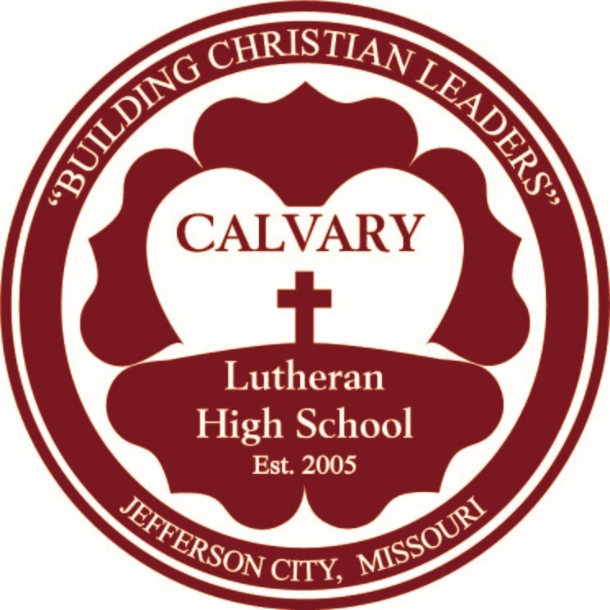**LION ACCOMPLISHMENTS** – Calvary Boys and Girls Track teams did an exceptional job at the Sectional Track Meet. 20 student-athletes qualified to compete in the Class 1 State Championship meet this past weekend! The Calvary Archery team had a very successful year and ended the season competing in Nationals in Louisville Kentucky last weekend.

**CALVARY BENEFIT GOLF TOURNAMENT** – Register your team today for June 8 at Tanglewood! Flights will begin at 8:00 and 1:00. Enjoy a great day of fun in support of Calvary students.

**VOLUNTEERS NEEDED** – Individuals with or without golf knowledge would be welcomed as volunteers for all or part of the day for the golf tournament on June 8. We also have opportunities to serve at Calvary throughout the summer – whether mowing grass or growing grass (keeping the soccer field watered for the seed to grow) or other projects. Contact John Christman with your interest.

**THRIVENT ACTION TEAMS HELP CALVARY**– If you are a Thrivent member, you have access to a program that would allow you to use $500 per calendar year on a service event or fundraiser ($250 at a time, for 2 events). Signing up is easy! Please consider putting your funds to use with a service event to spruce up the school, or to provide food for our Retreat in July, or to help with the Lutheran Educators Conference of Mid-MO. (We have a list of multiple projects!)

**WISHLIST UPDATED –** Check out our updated wishlist on our website if there are specific areas you would like to bless Calvary this summer!

**MATCHING GIFT OPPORTUNITY –** Ground has been broken on the multi-purpose (soccer) field at Calvary. Thank you to all who contributed to the matching fund challenge to make this possible! Additional contributions can be matched for music & drama programs (upto $10,000), for a school bus (upto $7,500) or for finishing the interior of our lunchroom. All projects will bless students at Calvary! Please consider helping multiply these blessings.

**POSITIONS AVAILABLE** – Calvary is still seeking qualified candidates for the 2018-2019 school year. The following part-time teaching positions are available: 1 period of Band and 1 period of dual credit English. (Dual credit teachers must have a Masters with 18 hours of post-graduate work in the subject area.) In addition, Calvary is seeking both Soccer and Cheer coaches. Resumes will be accepted until the positions are filled. They should be submitted to Calvary at 2525 Route B, Jefferson City, MO 65101.

**SERVANT SCHEDULE**

|  |  |  |  |  |
| --- | --- | --- | --- | --- |
|  |  | ***This Week*** |  | ***Next Week*** |
|  |  |  |  |  |
|  | **Pastor** | Pastor Powell |  | Pastor Powell |
|  | **Organist** | Caley Gerth |  | Caley Gerth |
|  |  |  |  |  |
| ***Saturday***  ***6:00 pm*** | **Reader** | Gary Barkhaus | ***Saturday***  ***6:00 pm*** | Dennis Nickelson |
| **Elder/Deacon** | Keith Schwinke Nate Roettgen | Leland Fischer Gary Barkhaus |
| **Ushers** | Dan Beck Team | Carol Fischer Team Matt Fife Team |
| **Greeters** | Jan Kliethermes Charlene Early | Dorothy Fischer Shari Fischer |
| **Acolytes** | Kyle Hagemeyer Jack Hartenstein | Abigail Gooch TJ Kirk |
|  |  |  |
| ***Sunday***  ***8:00 am*** | **Reader** | Marc Kollmeyer | ***Sunday***  ***9:30 am*** | William Schatte |
| **Elder/Deacon** | Ed Rakow Randy Seidel | Randy Seidel Robert Fluegge |
| **Ushers** | Ross Walquist Team | Ralph Robinett Team |
| **Greeters** | Tammy Homfeldt Betty Homfeldt | Bethel Johnson Susan Dierking |
| **Acolytes** | Elena Myers Christian Wachter | Adam Johnson Willow Garwood |
| **Nursery** | Lynda & Emma Kammeier | Kim Schmidt |
|  |  |  |
| ***Sunday***  ***10:30 am*** | **Reader** | Emmett Spradlin | Summer Schedule  begins week of  May 27 | |
| **Elder/Deacon** | Brent Fischer Larry Beck |
| **Ushers** | Kevin Bateman Team |
| **Greeters** | Chris & Anne Fehr Sharon Doan |
| **Acolytes** | Katie Spilane Christian Wachter |
| **Nursery** |  |
|  |  |
|  | **Pews** | Connie Kirchner Linda Smith Deb Schuleberg |  | Pat Mantle Bethel Johnson |
|  | **Heisinger** | Leland Fischer |  |

# THIS WEEK AT TRINITY

*Bible readings for the week*

*can also be found in LSB 299*

## Sunday May 20

*Numbers 21:10-35*

*Luke 21:20-38*

8:00 am Divine Service

9:15 am Bible Study (FH/BR)

Sunday School (Class)

10:30 am Divine Service

## 12:00 pm New Member Meal (FH)

## 6:00 pm Jr. Youth Crossover

## Monday May 21

*Numbers 22:1-20*

*Luke 22:1-23*

8:00 am Quilters (FH)

## Tuesday May 22

*Numbers 22:21—23:3*

*Luke 22:24-46*

9:00 am Lifeline Exercise (FH)

6:30 pm Council Meeting (Lib)

## Wednesday May 23

*Numbers 23:4-28*

*Luke 22:47-71*

9:30 am Lectionary Class (Lib)

7:30 pm College/YA Bible Study

**Online Lutheran Broadcasts:**

-Lutheran Public Radio (Issues, Etc.)

lutheranpublicradio.org or issuesetc.org

-KFUO Radio

KFUO.org

-Lutheran Hour Ministries

lutheranhour.org or lhm.org

(both sites have archived LH sermons you can choose by date)

## Thursday May 24

*Numbers 24:1-25*

*Luke 23:1-25*

9:00 am Lifeline Exercise (FH)

6:30 pm Choir

6:30 pm Usher Meeting (FH)

## Friday May 25

*Numbers 27:12-23*

*Luke 23:26-56*

## Saturday May 26

*Numbers 32:1-6, 16-27*

*Luke 24:1-27*

6:00 pm Divine Service

## Sunday May 27

*Numbers 35:9-30*

*Luke 24:28-53*

**SUMMER WORSHIP SCHEDULE BEGINS**

8:30 am Bible Study (FH/BR)

Sunday School (Class)

9:30 am Divine Service

5:30 pm Youth Praise Band

6:30 pm Jr. Youth (YR)

7:15 pm Sr. Youth (YR)

**HIGH SCHOOL GRADUATION RECOGNITION -** We will recognize the 2018 High School Graduates during the **May 20th** 10:30 church services.  All 2018 High School graduates are asked to join us at for cake between services.  We will take a group photo at 10:00.  Afterwards we will sit together during the 10:30 service for a special prayer and presentation. Please give Angie your Senior Picture to put on the bulletin board so we can see where you will be going and what you will be studying. Include your full name, parents name, your plans after high school and what you will be studying.  Please contact Angie Brenner if you have any questions

**Youth**

**ATTENTION ALL 8TH GRADE TRINITY MEMBERS -** Sometime during the month of May or June you will receive a special invitation to cross over to Sr. Youth, Stand Firm. Keep one eye open and always be on the lookout.

**ATTENTION ALL 5TH GRADE TRINITY MEMBERS -** We want you to join our S.W.A.T team (Junior Youth Program). We spend Sunday evenings learning to Serve, Worship, And Trust in Jesus. Please join us Sunday afternoon, **May 20th** at 6pm in the youth room for our “welcome” BBQ and an evening of fun and games.

**TEENS ENCOUNTER CHRIST (TEC)** will be held on **June 2nd – 4th**, 2018 at Immanuel Lutheran Church, Honey Creek, MO. TEC is a three-day retreat for teens AND adults that allows them to encounter the presence of Christ in their lives in a unique way. If you want to find out more about this amazing opportunity to grow in your faith, please visit our new website, www.heartofmotec.com. The website has all information and an online application. If you want more information you can call or text Sam Ziegelbein at 573-680-6887 or email TEC at heartofmotec@gmail.com. Please prayerfully consider supporting this important ministry with your prayers, by attending, or by donating needed items.

**HEITS POINT SUMMER CAMP**

The 2018 Summer Camp theme is “Journey” and the camp brochure and all camp registration forms are available on their website. We hope you have already made plans to send your children to Heit’s Point as repeat campers or for the first time this year! Camp school grades are in parentheses.

Jun 3–8 Outpost Adventure (5-8)

Jun 5–8 Mini-Quest (3-4) & Discovery (1-2)

Jun 10–15 Adv. Horse Camp (4-8)

Jun 10–15 Fishing Camp (3-8)

Jun 17–22 Paintball Camp (5-H.S.)

Jun 24–29 U-Pick Junior (age 8-12)

Jun 24– 29 Horse Camp (3-6)

Jul 4–7 Family Camp

Jul 4–7 Special Needs Camp

Jul 8–13 Night Owl (5-8)

Jul 8–13 Adv. Horse Camp (4-8)

Jul 15–18 Mini-Quest (3-4) & Discovery (1-2)

Jul 15–20 H2O Adventure (H.S.)

Jul 22–27 U-Pick Sr. (ages 13-17)

For more information call (660) 668-2363, go to heitspoint.com, or contact Gary Barkhaus at (573) 635-9872.

**VBS VOLUNTEERS:** VBS will be held **June 18 – 22** from 6:00pm – 8:00pm. If you would like to share your talents with the youth of our community, please contact Angie Brenner at angbrenn@hotmail.com. Our upcoming meetings are at 5:30 in the Youth room on the following days: **May 24th, June 7th, and June 14th**. We would love to have you as a part of our team!



**Lutheran Family &**

**Children’s Services**

is looking for help to

build and support families.

Empty baby bottles in the church lobby are provided by LFCS, and individuals are asked to fill the bottles with loose change, bills and even checks. The filled bottles come back to LFCS like a boomerang to help the families we serve.

LFCS, Mid-Missouri office facilitates this project with your church beginning **Mother’s Day, May 13, 2018**

and the bottles are returned to church on

**Father’s Day, June 17, 2018.**

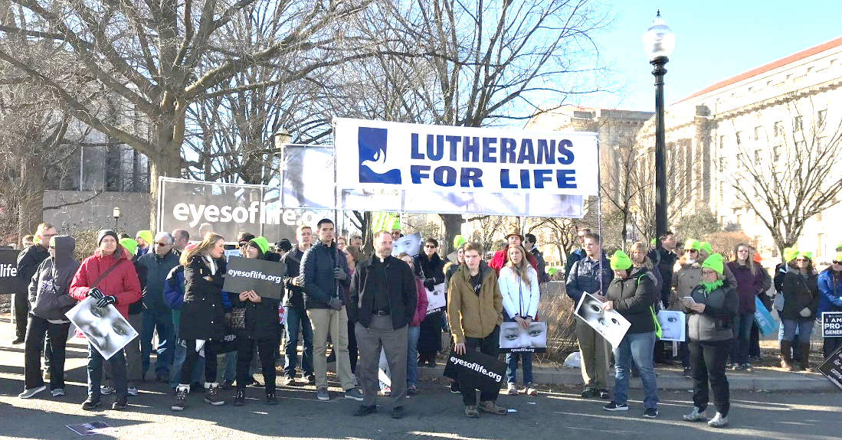

The Capital Area Lutherans for Life have booked a bus for the 2019 March for Life, leaving Wednesday, January 16 and returning Saturday, January 19.

Mark your calendars and let Elaine Ott know if you are interested! 573-619-6608 or meow074@aol.com

2019 March for Life

Washington D.C.

Friday, January 18

The **2019 LCMS Life Convention** is also due to occur during the March for Life in Washington DC!

This only occurs every two years, so don’t miss out!



All are welcome to join

starting Sunday, May 6th

during Sunday school hour

in the board room.

Discussion facilitated

by Ryan Brunner.

**Trinity Men’s**

**Softball Schedule**

|  |  |  |  |  |
| --- | --- | --- | --- | --- |
| **Week 1** | | | | |
| Mon 5/14 | 7:15 PM | Central Baptist Church | Trinity Lutheran | Wisch Field |
| **Week 2** | | | | |
| Mon 5/21 | 6:15 PM | Trinity Lutheran | Fairgrounds Road Church of Christ | Wisch Field |
| **Week 3** | | | | |
| **Memorial Day Holiday** | | | | |
| **Week 4** | | | | |
| Mon 6/4 | 9:15 PM | Trinity Lutheran | Concord Baptist | Wisch Field |
| **Week 5** | | | | |
| Mon 6/11 | 8:15 PM | St. Martins | Trinity Lutheran | Wisch Field |
| Mon 6/11 | 9:15 PM | Fairgrounds Road Church of Christ | Trinity Lutheran | Wisch Field |
| **Week 6** | | | | |
| Mon 6/18 | 6:15 PM | Trinity Lutheran | St. Peter | Wisch Field |
| **Week 7** | | | | |
| Mon 6/25 | 8:15 PM | Trinity Lutheran | Central Baptist Church | Williams Field |
| **Week 8** | | | | |
| Mon 7/2 | 6:15 PM | First Baptist Church | Trinity Lutheran | Wisch Field |
| **Week 9** | | | | |
| Mon 7/9 | 9:15 PM | Trinity Lutheran | Capital West Christian Church | Williams Field |
| **Week 10** | | | | |
| Mon 7/16 | 7:15 PM | United Methodist Church | Trinity Lutheran | Williams Field |



**If you have a Thrivent Action Team that you have not used and would like to help projects at church, please contact the church office.**